**School Parliament – Autumn**

**5.12.24**

Present: Neveah (Y6), Dexter (Y6), Joshua (Y5), David (Y4), Freya (Y4), Ronnie (Y3), Albie (Y2), Penny (Y2) and Miss Jamieson

We discussed the structure of our School Parliament and created four different departments:

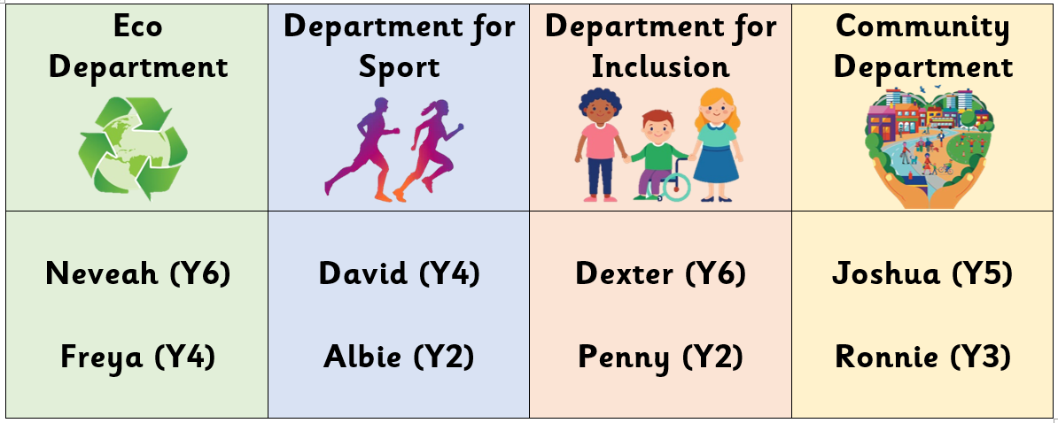

The Eco Department focuses on looking after the environment and making sure our school is eco-friendly.

The Department for Sport is all about staying fit and healthy.

The Department for Inclusion is about making sure everybody is included no matter their appearance, beliefs, strengths etc. We want to make sure everybody is included in learning and playtimes.

The Community Department are going to think about looking after our school and local community, as well as raising money for charities.

We discussed some ideas children already have:

|  |  |
| --- | --- |
| **Eco**  **Department**  clipart eco 10 free Cliparts | Download images on Clipground 2024 | * Posters could be made to encourage people to switch off the lights when a room is empty. * We could have a wider variety of recycling bins e.g. a plastic bin as well as paper. * We are interested to find out, where does our food waste go? * A request has been made for a gardening club/group – to complete planting and to look after our school grounds. * Children would like the hill area re-designed to be used as a nature area/area for outdoor learning. |
| **Department for Sport**  Runner PNG Transparent Images | * Requests have been made for new footballs to be available for playtimes and more equipment in playground boxes. * Some children would like to have small sports tournaments within school (like Quad Kids which Year 5 completed last year). * Positive feedback has been given about PE clubs which already exist in school. |
| Premium Vector | Three children are holding hands with a child in a ...**Department for Inclusion** | * Children would like more opportunities to work in groups in the classroom. * Some children feel that not everybody can join in at playtimes as football can take over most of the playground zone. Maybe we could have some football free days, or vary the sports which are played. * Y6 feel that feelings are very important and should be considered throughout school. A request was made for each class to have an opportunity to write down/say how they are feeling when they enter the classroom first thing in the morning and after lunch. |
| Aviva - Local Community Community Clipart, HD Png Download ...**Community Department** | * Posters could be made to encourage people to pick up litter in the local area. A litter pick could be arranged. * Children would like to have a £1 non-uniform day to raise money for a local food bank or the community centre. * Some children suggested we could hold a book swap/sale in school with unwanted books from home for both children and parents. |

Actions:

Each member of School Parliament is going to talk to their class about the issues discussed and gather any feedback/ideas before the next meeting (17.2.25).

|  |  |
| --- | --- |
| **Eco**  **Department**  clipart eco 10 free Cliparts | Download images on Clipground 2024 | * If any children would like to make posters to encourage people to switch off lights, these could be displayed in classrooms/corridors. * Neveah/Freya speak to Mrs Walker/Mrs Jones about the possibility of a gardening club and changing the hill. |
| **Department for Sport**  Runner PNG Transparent Images | * David/Albie to discuss with Miss True about the possibility of extra playground equipment and sports tournaments. |
| Premium Vector | Three children are holding hands with a child in a ...**Department for Inclusion** | * Classes to trial a football free day, or vary the sports which are played. * Group work and feelings to be discussed with teachers. |
| Aviva - Local Community Community Clipart, HD Png Download ...**Community Department** | * Ideas discussed to be discussed with Mrs Ashton. |