KS2 SATs 2023

Information for Parents

When are the tests?
This year’s KS2 test dates will be from the 9th - 12th May 2023.

What do the SATs test?

The national curriculum tests at the end of Key Stage 2 are administered in mathematics, English reading and English grammar punctuation and spelling.

Assessment and Reporting
•Test scores are reported as ‘scaled scores’.
•A scaled score of 100 represents the expected standard on the test.
•Pupils scoring 100 or more will have met the expected standard on the test.

Scaled Scores Examples
•A child awarded a scaled score of 100 is judged to have met the ‘national standard’ in the area judged by the test.

•A child awarded a scaled score of more than 100 is judged to have exceeded the national standard and demonstrated a higher than expected knowledge of the curriculum for their age.

•A child awarded a scaled score of less than 100 is judged to have not yet met the national standard and performed below expectation for their age.

Time Allowed for Tests

Reading (60 minutes)
Spelling (approximately 15 minutes)
Punctuation, Vocabulary and Grammar (45 minutes) Mathematics
- Paper 1: Arithmetic (30 minutes)
- Paper 2: Reasoning (40 minutes)
- Paper 3: Reasoning (40 minutes)

All tests are externally marked.

Writing will be ‘Teacher Assessed’ internally, as in recent years.

Reading
- The Reading Test consists of a single test paper with three unrelated reading texts.

- Children are given 60 minutes in total, which includes reading the texts and answering the questions.

- A total of 50 marks are available.

- Questions are designed to assess the comprehension and understanding of a child’s reading.

- Some questions are multiple choice or selected response, others require short answers and some require an extended response or explanation.

Sample Questions
Find and copy one word that suggests that the spring morning was peaceful.
Look at the paragraph beginning: Towering and majestic... What impressions do you get of the mountain from this paragraph?

What was revealed at the end of the story? Tick one option from this list

Spelling, Punctuation and
Grammar
•A Spelling test is administered containing 20 words, lasting approximately 15 minutes.

•A separate test is given on Punctuation, Vocabulary and Grammar which lasts for 45 minutes.

•Marks for these two tests are added together to give a total for Spelling, Punctuation and Grammar.

Sample Questions
Grammar, Punctuation and Spelling Paper 1 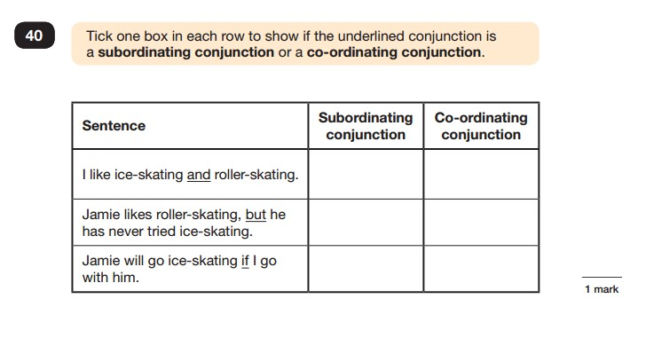

Maths
- The Mathematics tests have undergone the biggest change this year.

- Children will sit three tests: Paper 1, Paper 2 and Paper 3.

- Paper 1 is for ‘Arithmetic’ lasting for 30 minutes, covering calculation methods for all operations, including use of fractions, percentages and decimals.

- Papers 2 and 3 cover ‘Problem Solving and Reasoning’, each lasting for 40 minutes.

- Questions gradually increase in difficulty. Not all children will be expected to access some of the more difficult questions later in the paper.

Sample Questions
Maths Paper 1: Arithmetic
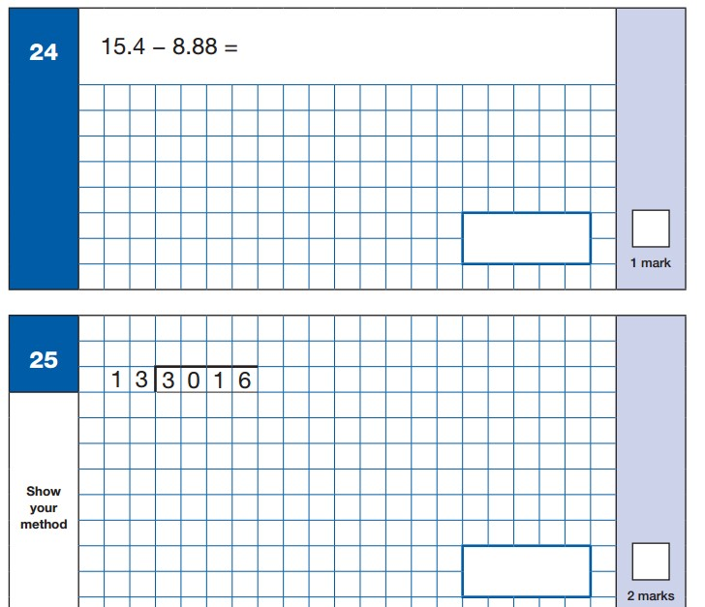
Sample Questions
Maths Paper 2 / Paper 3 : Reasoning 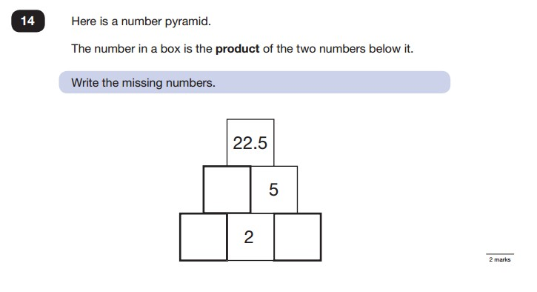
Sample Questions
Maths Paper 2 / Paper 3 : Reasoning
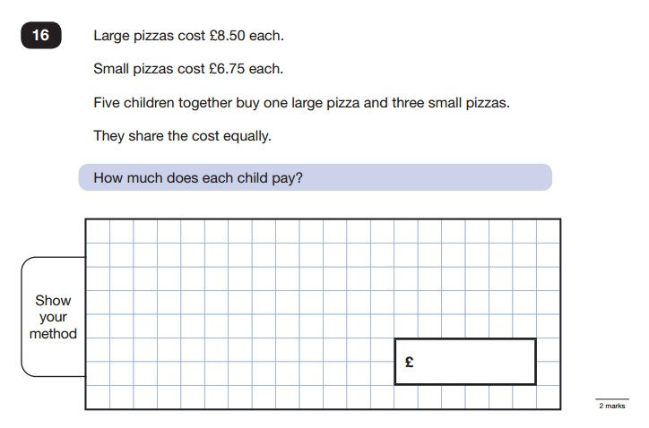
How can I help my child?
- In general:
- Praise and encourage!
- Ensure your child has the best possible attendance at school.
- Support your child with any homework tasks.
- Listen to them read and support them with the learning of spellings and tables.

In SATs week:
- Make sure your child has a good sleep (no sleep-overs!) and arrives at school in good time.
- Encourage them to have something to eat and drink for breakfast.

