Reception 2021- 22 | Autumn 1 | Autumn 2
Theme | All About Me/Family  Autumn | Celebrations: Bonfire Night, Diwali, Christmas  Light and Dark
Communication and Language | 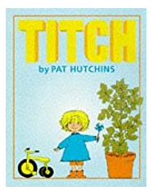  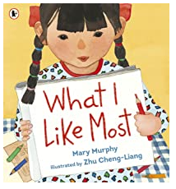  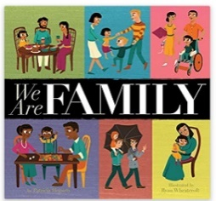  We Are Family What I Like Most Titch  Three Little Pigs | 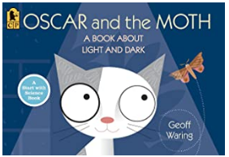  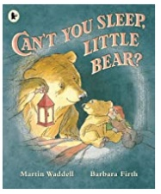  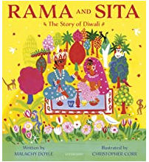  Rama and Sita Oscar and the Moth Can’t you Sleep Little Bear
Personal Social and Emotional development | See themselves as a valuable individual  (Between Us books) | Build constructive and valuable relationships
Physical Development | Movement skills ie hopping, skipping, jumping  Develop small motor skills, to use pencils, paint brushes, scissors, knives, forks and spoons | Movement skills ie hopping, skipping, jumping  Continue to develop small motor skills, to use pencils, paint brushes, scissors, knives, forks and spoons competently
Literacy | Phonics phase 2 | Phonics phase 2
Mathematics | Subitise – Recognise small groups of quantities in familiar patterns (for example, dice) and random arrangements up to 6  To recognise and name familiar 2D shapes, square, rectangle, triangle and circle  Make a repeating pattern using 2 shapes or colours | Linking numerals alongside quantities.  Select, rotate and manipulate shapes to create other shapes  Compare and discuss different weights encouraging children to use the word ‘than’, eg “This is heavier than that.”
Understanding the World | Talk about members of their immediate family and community. | Recognise that people have different beliefs and celebrate special times in different ways.  Explore the natural world around them.
Expressive Arts and Design | AccessArt self-portraiture  Explore, use and refine a variety of artistic effects to express their ideas and feelings. (Colour-mixing) | Bonfire pictures  Diwali lamps  Mehndi designs  Create collaboratively, sharing ideas, resources and skills
Curriculum Enhancement | Little Fingers Music  Sing in a group or on their own increasingly matching the pitch and following the melody | Little Fingers Music  Sing in a group or on their own increasingly matching the pitch and following the melody

