Firthmoor Primary School
Ingleby Moor Crescent, Darlington, DL1 4RW
Tel: 01325 244001 ● Fax: 01325 244555
Email : admin@firthmoor.darlington.sch.uk
Website : http://www.firthmoor.darlington.sch.uk

Headteacher – Mrs A Dixon

13th September 2021

Dear Parent/Carer,

School photographs 2021

The school photographers will be in school on the morning of Thursday 23rd September.

Every child in school on that day will get an individual picture taken.

If you would like a photograph taken of any siblings within school, please email us on admin@firthmoor.darlington.sch.uk, giving the names of each child to be included in the group. The deadline for us to receive an email is Sunday 19th September.

Unfortunately, on this occasion, we cannot invite family members who do not attend Firthmoor Primary to be included in any photographs.

Yours faithfully
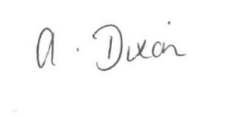
A Dixon
Headteacher

