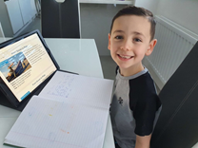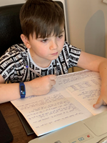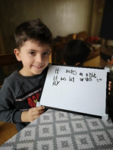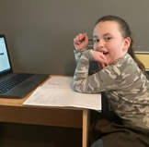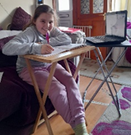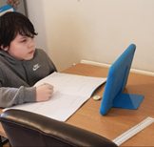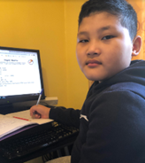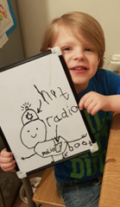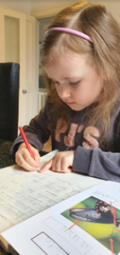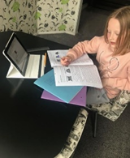
Upcoming Date Reminders
Friday 26t^{h} March – Break up for Easter holiday
Monday 12t^{h} April – Return to school after Easter holiday
Monday 3r^{d} May – Early May Bank Holiday (school closed)
Music at Firthmoor

We were pleased that the pupils didn’t miss out on their music lessons throughout lockdown, as they were taught violin remotely by Miss Howard via ‘Teams’.
Miss Carr ‘zoomed’ into the class for recorders.
Last week saw the return of our peripatetic music teachers in school for face-to-face, teaching now that all children have returned.
World Book Day 2021

On Thursday 4th March, the whole school, including those remote learning, took part in World Book Day.

Children got involved in various World Book Day activities, including sharing their favourite books with their classmates, listening to audio books, designing a book token, making a book mark, scavenger hunts and watching videos about their favourite author, plus lots more.

Some children enjoyed a virtual assembly hosted by David Walliams and some took part in an interview with award-winning author, Tom Palmer, where they were able to put their own questions to him.

Children each received a £1 book token to redeem their World Book Day offer or to discount any book purchase of £2.50 or over.

The day was thoroughly enjoyed by both pupils and staff alike, and you can see photographs of all the fun on our website, in the ‘recent news’ section (web address at the top of this page).
Lockdown Star Learners

Thanks to the generosity of a local resident, the school received a donation to encourage and reward pupils who were working hard during lockdown.
Every week, it was a very difficult task for the staff to choose just one pupil, as many children (too many to mention everyone), worked very hard and turned in quality work to their teacher regularly.
The pupils in the photographs above stood out as those doing work ‘above and beyond’ what was asked of them, every day.
These pupils were asked to pick £30 worth of books of their choice from Amazon, which were delivered directly to them at home.
Well done, not only to those pupils, but also to those who put in maximum effort with their remote learning.
A special mention also goes out to all those parents who turned into temporary teachers while their children were off school, many of whom were working themselves, either from home or as essential workers, but still supporting their children the best they could.
Well done everyone!

Charity involvement
This year, as always, Firthmoor Primary will be getting involved in raising money for charity.
We will be taking part in Red Nose Day, which takes place this Friday 19th March, where everyone will be invited to wear red for a donation of £1.
We will also be getting involved in ‘Demin for Dementia’, taking place on Friday 26th March, where everyone will be
invited to wear denim,
also for a donation of £1.

Firthmoor Primary School Newsletter
Spring Term 2021 www.firthmoor.darlington.sch.uk

Sport and Fitness

We are pleased to have welcomed back into school, the team at Sporting Futures, who do PE lessons with the children, supported by our PE apprentice, Mr Woodward.
The children are taught a variety of sports and techniques by Sporting Futures, and are currently learning ball games.
As well as this, the children are encouraged to take part in ’30 active minutes’ in school – this could include a jog around the ‘red mile’, or joining in a dance routine in the hall. Some of the children have been learning the dance routine to Jerusalema - you may have seen it, as it is the latest dance craze to sweep the Internet. It has been replicated and placed on YouTube by organisations across the globe, from the crew at Austrian Airlines to a Swiss police force. The steps are extremely easy and the children have picked it up quickly, making it a fun way for them to keep fit and active. Take a look at some of the videos on YouTube.

Game of Actual Life - SCSS

We have been fortunate enough to be able to welcome back into school, Simon Carson and his staff to deliver the GOAL programme, this time to our Year 4’s and 5’s

GOAL is a fun and engaging way to deliver invaluable life skills to the children, giving them an insight of life ‘in the real world’, from handling money to living happier and healthier as an adult.
The programme covers five key areas;

‘Keep in Credit’, ‘Keep Learning’, ‘Keep Fit’, ‘Keep Calm’ and ‘Keep Safe’.

The programme covers a wide range of topics from buying a car to buying a house/mortgages, all of which are delivered in a practical way whilst supporting Maths, English and other subjects.


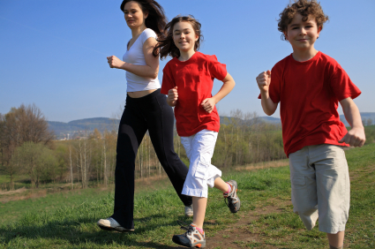
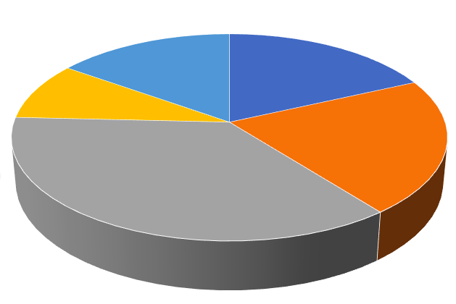
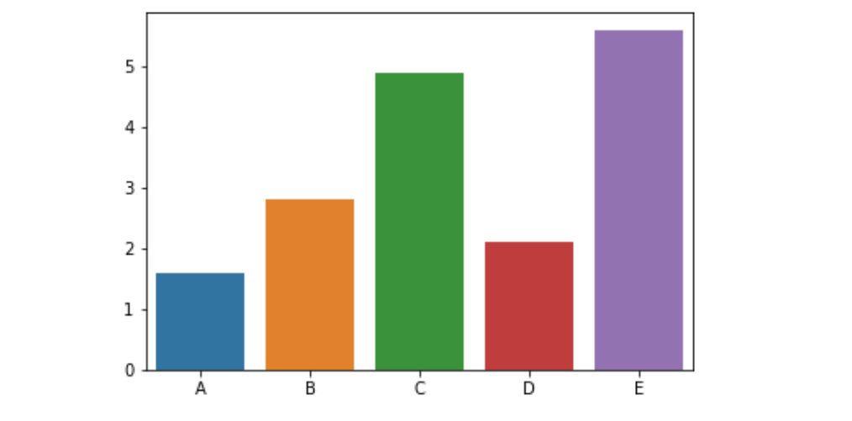
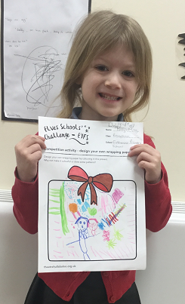
For the safety of everyone…………

Thank you to those parents who are wearing face coverings on the school premises when dropping off and collecting children…..we ask you to do this for everyone’s safety.
Once you have dropped off/collected your child, please leave the premises as quickly as possible.

We would like to thank you for your continued support in making our collection gates and one-way systems work efficiently, and also for adhering to our ‘one person per collection’ request. These rules are in place for the safety and peace-of-mind of everyone in our school community.
It is wonderful to see that everyone is trying to be kind and respect one another through this difficult time.
We are almost there – but not quite, so we must continue as we are until the pandemic is behind us.
Thank you.

Let’s count ‘mini census’
The children undertook their own ‘mini census’ as part of a Maths project in school, Let’s Count!
Year groups surveyed and counted different objects/actions to be displayed in mathematical format such as pie chart, pictogram etc.
Among the items counted were; favourite fruit, displayed as a pictogram, counting minibeasts, displayed as a tally chart, steps in a mile, displayed as a pie chart/scatter graph and most common book characters, displayed as a pictogram.
Changes in contact details, circumstances & meal arrangements

Please could we ask that you inform the school office by email of any changes in your circumstances or contact details (phone number, address, email etc). It is very important that we are able to contact you throughout the school day about your child if it becomes necessary. Thanks.
Please could you let us know by email if you intend to change your child over from packed lunch to school meal and vice versa, so that we can update our system, and if your child is in Yea 3 or 4, we need to know via email if their home-time arrangements change as we cannot act upon verbal requests.
Thanks.

The email address is;
admin@firthmoor.darlington.sch.uk
Year 6 In2 Project

You may remember seeing on our website, our previous Year 6’s involvement with the In2 Project.
Working collaboratively with Darlington Hippodrome, the In2 Project’s main focus is to support our Year 6 children with their transition into Year 7/8.
Throughout the project, they will work with Back Chat! Brass Band, where they will learn to play an instrument and produce a ‘show’ at the end.
Let’s not litter!

Our Year 2 pupils have been out in the community with their teacher doing a ‘litter survey’.
As part of their work in Literacy, they brought the results back into school to do some persuasive writing, encouraging people not to drop their litter and to dispose of it properly.
All wrapped up!
Lilly-May in our Reception class had the first prize all wrapped up in a competition she entered before the current lockdown, run by Theatre Hullabaloo in Darlington.
The competition was to design some gift wrap, and the judges at Hullabaloo were very impressed with Lilly-May’s design.

Her prize was a visit to Darlington
Hippodrome for her class, which will be
arranged once lockdown and social
distancing restrictions are lifted.

Well done Lilly-May.

