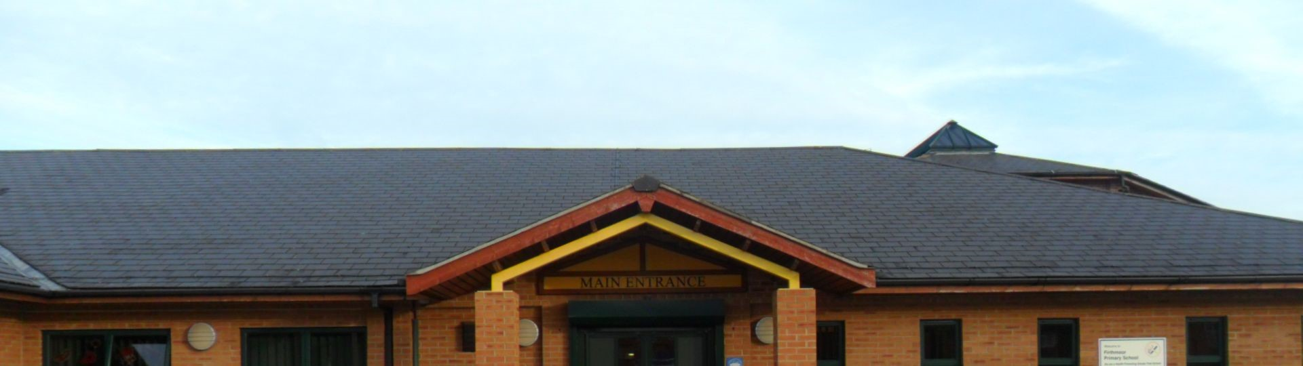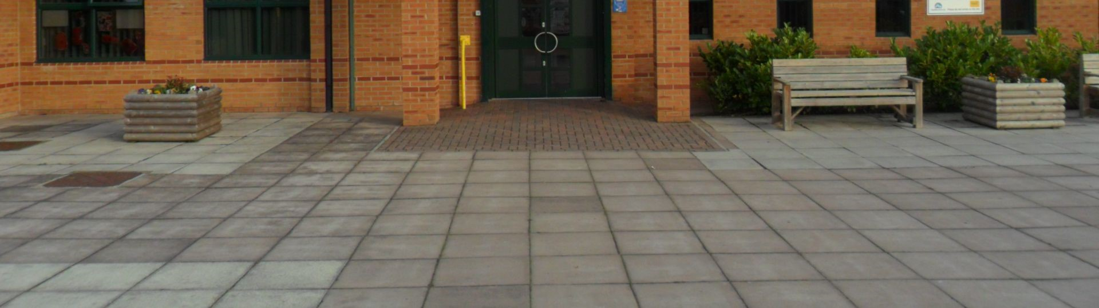

Firthmoor Primary School Prospectus

Firthmoor Primary School
An Academy Trust - Registered Number - 8027879
Ingleby Moor Crescent,
Darlington,
Co Durham,
DL1 4RW
Tel. 01325 244001
Fax. 01325 244555
e-mail - admin@firthmoor.darlington.sch.uk website- http://www.firthmoor.darlington.sch.uk

Head Teacher – Mrs A Dixon

Dear Parents/Carers,

I am delighted that you have shown an interest in enrolling your child in our school.

I hope that the information you find in this brochure will be useful in providing you with a clear overview of our school.

May I take this opportunity to say that if you have any further questions now or in the future, please do not hesitate to contact me.

We aim to make every child’s time here at Firthmoor Primary a secure, happy and successful experience.

Kind regards

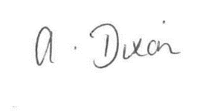

Mrs. A Dixon
Headteacher

All about our school

Values and Ethos
At Firthmoor Primary School, we are dedicated to providing the very best care and education for all our children. We want our school to be a happy, inclusive and successful community.

Within a safe, positive and supportive environment, our children are encouraged to take responsibility for their own health and well-being. We promote a love of learning, which encourages our children to aim high and become valuable members of society.

We pride ourselves on being a school at the heart of the Firthmoor community, involving pupils, parents and the wider community in our achievements.

At our school we will:

- care for your child’s safety and happiness and provide a secure, caring and stimulating place to aid your child’s development
- encourage and support your child to do their best at all times
- develop high standards of behaviour and self esteem.
- value and encourage each child whilst encouraging them to respect each other, their belongings and school surroundings.
- inform you about your child’s progress each term.
- inform you about school activities through regular letters home
- inform you if there are any concerns about your child’s progress, attendance or behaviour.
- provide all children, wherever possible, with equal access to school activities and opportunities, to promote the highest standards of attainment and teaching.
- provide a broad, balanced curriculum, which is monitored and evaluated.
- develop our children as tomorrow’s citizens.

The School Day
The school operates a free breakfast club for all Y1 to Y6 pupils which runs from 8.15 am each day.

School begins at 8.55 am. and ends at 3.05 pm.

It is important that children arrive before lessons begin, otherwise they may miss valuable teaching. We do ask, however, that children do not arrive at school before 8.45am. as it is not practical to supervise them, unless they are attending our free breakfast club which operates from 08.15 until 08.45.

Nursery
Our Nursery provides a free breakfast club from 08:15am each day. We operate a Morning session only 9.OOam. to 12.00 noon to support the 15 hours free childcare available to 3 and 4 year olds. (doors open from 11.50am. for consultation with Nursery staff).

Lunchtime
Key Stage 1 have between 45 mins to 1 hour and Key Stage 2 have 30 mins to 45 mins between the hours of 11.45 am and 1.OO pm.

Our main aim is the safety of the children. It is vital that parents keep themselves and their children away from the gates and the road areas. Parents are not permitted to use the staff car park at any time, but should park outside away from the restricted zones. In the interests of health and safety, dogs are not permitted onto school grounds.

We have security locks on all external doors. When the doors are closed, shortly after school commences, children are unable to gain access to the building except by the main door. If your child arrives after 9.00am, please escort them to the main door.

Safety at home time
At the end of the day, children leave school from several doors to ease congestion.

Key Stage 1
For the safety of the children, pupils from Nursery to Year 2 need to be collected by a parent, carer or other appropriate adult over 16 years of age. Parents need to contact the office if their child is to be collected by someone unfamiliar to school.

We will never allow a KS1 child to go home alone or with a child under 16 years of age.

Key Stage 2
Older children may make their own way home after school. However, we find that some parents still like to collect their child from school.

The School Curriculum
We aim to provide a broad, balanced and relevant curriculum matched to each child’s needs. Emphasis is placed upon helping your child to speak and listen, read and write and to work with numbers.

English, Mathematics and Science are the core subjects. The curriculum also includes Computing, History, Geography, Design Technology, Art, Music, PSHE and a Modern Foreign Language.

Phonics is taught throughout the school on a daily basis as part of the children’s reading. Letters and Sounds is used to plan a variety of phonic based activities in line with the phase that they are currently working at. The Oxford Reading Tree series of books are used throughout the school as part of the children’s reading.

Children are given the opportunity to work in many ways as a class, group or individual.

Subjects may be taught on their own or as part of a larger topic covering a number of subjects.

Relationships and Sex Education
An important part of education in our school is to foster feelings of selfesteem, self respect and respect for the needs and feelings of others. The development of such a positive and responsible attitude is basic to relationships and sex education.
Our Relationships and Sex Education is linked with the Personal, Social and Health Education and Science curriculum. Issues are dealt with informally as opportunities or questions arise. Towards the end of Key Stage 2 children participate in informative sessions led by the school nurse.
Parents are informed at that time and are welcome to discuss this aspect of their child’s education if they have any concerns.

Religious Education and worship
Religious Education is taught in accordance with the law and the Local Authority Agreed Syllabus. It encompasses Christian values and traditions but knowledge of other world religions is also taught to reflect society as a whole.
Whole school, key stage or class assemblies take place each day and parents are regularly invited to take part. An important part of our teaching is the encouragement of caring attitudes both for mankind and the environment and the development of moral values. All children attend these lessons and assemblies but, if any parent wishes to withdraw their child from this aspect of school life, they should discuss this with the Head teacher.

Personal and Social Education – Citizenship
We aim to promote the spiritual, moral, cultural, mental and physical development of every child in our school. We plan activities as well as visits to and from the local community and businesses to help children prepare for the opportunities and experiences of life as a responsible citizen.

Homework
We feel that parents can contribute in an enormous way to their children’s reading development if a few minutes are spent each evening on reading activities. Reading books are sent home on a regular basis and, at both Key Stages, pupils are assigned homework according to the school homework policy.

Testing and Assessment
Nursery and Reception are assessed according to the Foundation Stage Profile
Year 1 Phonics Testing
Year 3, 4, 5 Internal Testing
Year 2, 6 All children participate in the National Tests

Children with Special Needs
All class teachers differentiate classroom work to meet the needs and abilities of individual children. Each child’s progress is monitored on a half-termly basis. When a child’s progress is causing concern, teachers will discuss the issues with parents. It may be necessary to place the child’s name on the Special Needs Register according to the Government’s Code of Practice. This will enable staff to closely monitor an individual child and prepare a school support plan which will be reviewed regularly. It may be that a child’s needs are sufficient to warrant a formal assessment by outside agencies such as an Educational Psychiatrist, Social Services or Behaviour Support.

Disabled Access
The school has specially designed features to enhance disabled access. There are no steps and corridors and doorways are wide enough for wheelchair access. There are two disabled toilets located within the building.

Behaviour and Discipline
We are proud of the caring ethos fostered by all members of staff in our school. An essential part of this is our school code of conduct, which ensures good order, discipline and the safety of our children whilst fostering respect for each other and ourselves.
Good behaviour and effort are constantly praised and the school has a system of merit awards.
However, occasionally, sanctions may need to be imposed which may result in a loss of privileges. In more serious cases, involvement of parents is invited and welcomed. We hope that parents and school can work together to encourage the child to modify his/her behaviour. In very serious or persistent cases the school, unfortunately, may have no choice but to exclude a child.

Educational visits and activities
We arrange a variety of educational visits to support learning during the year. These visits are beneficial to your child’s education but the cost cannot always be covered by the school budget. We therefore rely on your voluntary contributions - without this support visits could not go ahead. No child will be excluded from a visit because of parental inability to pay but the school may have to cancel a visit if insufficient funds are collected.

Charging and Remissions
Our School operates on a very tight budget and because of this, if school equipment is lost or wilfully damaged, we may request reimbursement by parents.

Admissions Procedure

Primary Admission Criteria
The governing body intends to admit up to 45 pupils are eligible to start school at the beginning of September. This number will apply to the Reception Year and to every other year group in the school.

1. Looked After Children
A looked-after child is a pupil who is in the care of a Local Authority or who is provided with accommodation by that authority.

2. Children previously in state care outside of England
Children who have been in state care outside of England and ceased to be in care as a result of being adopted.

3. Medical Reasons
Pupils with exceptional medical factors directly related to school placement. Applicants under this criterion should be supported by written evidence from a doctor.

3. Sibling Links
Pupils who have a brother or sister already attending the school and who is expected to be on roll at the school at the time of admission.

4. Distance
Pupils who live nearest the school by the shortest walking route. This will be based on the parents’ address. The authority will, however, consider the overall availability of school places in the area to ensure that no children have an unreasonable distance to walk. This may override proximity to the school.
Please note that in the event of over subscription within criterion 1) or 2) places will be granted to those pupils living nearest the preferred school (measured by the shortest walking distance)

School organisation

Nursery
The Nursery class has 39 places and offers 15 hours per week for each child from 9.00-12.00 each day. The Nursery operates in the morning only. In the afternoon, both the inside and outside areas of the Nursery are used by the whole of the Foundation Stage to allow children greater scope with their play and learning. If parents wish to register their child for a place in Nursery they may do so during the year in which their child has their second birthday. Early registration is recommended because places are limited. Children may enter the Nursery the term after their third birthday.

Entry to reception
The reception class has one intake in September and we operate a staggered intake.

1st Week - mornings with lunch (parents to collect children at 1.15pm) 2nd Week - full time. We find this system gently eases your child into school life
We have systems in place for Nursery, Key Stage 1 and Key Stage 2 pupils to become familiar with their next class on a structured basis before their transfer.

School Leavers

Pupils leaving our school attend a number of secondary schools in the town.

St Aidans Academy | Hurworth Academy | Polam Hall
Carmel College | Hummersknott Academy | Wyvern Academy
Education Village | Longfield Academy

Absence and holidays
The school operates a computerised registration system and we have a statutory obligation to monitor the attendance of all pupils. Please let us know the reason for your child’s absence, on the first day of absence. If we do not receive a valid reason we will have to mark him or her as unauthorised.

Taking children out of school
Wherever possible, please make routine medical and dental appointments outside of school hours.

Illness
School is not the place for children who feel ill regardless of how badly they wish to attend. Please contact school if you need advice on how long your child should remain at home following illness from childhood ailments.

Leave of Absence for Holidays during Term-Time
Government regulations do not allow schools to authorise leave of absence during term time unless there are exceptional circumstances. Please make an appointment to speak to the head teacher for further details if you have to take your child out of school for any reason.

Lateness
We place great importance on punctuality. Children who arrive late for school miss out on valuable teaching time and disrupt the learning of other children. Records are kept of children who arrive late for school and, in cases of frequent lateness, parents are invited into school to discuss how punctuality may be improved.

Medicines in school
There may be occasions when medication is necessary e.g. after an illness or an ongoing condition. For safety reasons, only prescribed medicines can be administered in school and when the dosage is 4 times a day. All medication, including Asthma medication, must be recorded and collected by an adult. A prescribed medication in school form must be completed each time there is a request for medication to be administered.

Asthma Medication
If your child suffers from Asthma, a prescribed medication in school form must be completed. You are also asked to make sure your child has two inhalers so one can be left at school.

School Uniform

Please ensure that your child’s clothing and belongings are labeled clearly with their name and class.

School uniform consists of a red sweatshirt, cardigan or jumper, a pale blue polo shirt for winter or summer, with the option of a red outdoor fleece. These items bearing the school logo may be purchased online from the school website. Our Suppliers are Brigade Clothing and Tesco online. Plain, non-logo uniform can also be purchased from most major supermarkets and high street stores.

The remainder of the uniform comprises of grey or black trousers/skirt and sensible shoes/trainers. (no high heeled or strappy footwear). All children should have a change of clothing and footwear for P.E. The red school P.E. t-shirts can be purchased from the school office. Plain black shorts and plimsolls or non-marking trainers should also be worn as part of the P.E. uniform. A warm top or tracksuit may be worn for outdoor P.E. in the colder weather. Jewellery should not be worn for P.E. for health and safety reasons and long hair should be tied back.

We ask parents and carers not to send their child to school with ‘extreme’ hairstyles, such as Mohican, patterned or brightly coloured hair, or with any sort of appearance that is likely to draw attention.

Sporting aims and provision
All children participate in sporting activities as part of their education. We encourage the acquisition of skills and promote the value of teamwork, fair play, competition, fitness and enjoyment.
The school has sole use of a large playing field, yard, M.U.G.A, a hall and a variety of large and small equipment.

Children take part in skills coaching, from both staff and outside organisations such as Darlington Football Club, Durham County Cricket Club and Darlington Rugby Club and we have our own sports teams who take part in local and district events. Children also take part in Cluster and Town sporting events.
Our curriculum also includes individual and team games and associated skills, gymnastics, dance, swimming (KS2 only) and athletics.

School meals
School meals are cooked on the premises. Currently the cost of a school meal is £2.00 per day (£10.00 weekly in advance) and parents are asked to pay for school meals each Monday morning.
Our cook and her staff take great care to make appetising and nutritional food and most children stay for school lunch.
If you feel you may be entitled to free school meals, even if your child is currently bringing a packed lunch, then please telephone or pop into the school for advice. Matters concerning them are dealt with in the strictest confidence. If you prefer to send a packed lunch for your child please observe the following guidelines:
~ The lunch should be placed in a container which can be carried by the child and stored in the school. Please bear in mind that we have no cool storage facilities.
~ Please try to ensure that the meal is healthy (only one bag of crisps and one cake/biscuit item).
~ Fizzy drinks, sweets and chocolates are not allowed.
~ For safety reasons please don’t send cans, glass bottles, hot drinks or soup.
~ Due to airborne allergies, Children should not bring nuts or items containing nuts into school.

Complaints procedure (School Curriculum, Religious Worship and related matters)
It is sincerely hoped that parents would raise any concerns they have with Head Teacher in the first instance. It is always best to call in and sort out the small problems immediately before they grow into big ones. Please don’t hesitate to contact us. However, if parents wish to make a formal complaint, please follow the guidelines within our policy, which is available on the school website. Any formal complaints can be addressed to Mr W Paton, Chair of Governors, c/o Firthmoor Primary School, Ingleby Moor Crescent, Darlington, DL1 4RW.

Parents and community

WE WELCOME PARENTS INTO OUR SCHOOL.
We try to answer queries as soon as possible. If parents feel that there is a matter they would like to discuss privately with the teacher, then please telephone or ask for an appointment out of school hours.
Parents will be invited to open afternoons or evenings throughout the year to allow them to view the educational development of individual children and in the Summer term, parents receive a report detailing progress made.
Parents are also invited to a range of assemblies, meetings and functions.

Please keep the school informed of any home situation which may be causing distress. We can then be sure to provide appropriate support and care a child might need.

Community
We aim to develop positive relationships with the local community. The school works closely with local organisations such as the Firthmoor Community groups, Social Services, Police, Local Industry and other schools and acadamies.

Child protection
Parents and carers should be aware that the school has a duty to take reasonable action to ensure the welfare and safety of all pupils. In cases where school staff have cause to be concerned that a pupil may be subject to ill treatment, neglect or other form of abuse, staff will follow Child Protection Procedures and inform Social Services of their concern. From time to time, it is necessary to contact outside agencies within Darlington Children’s Services in order to support your child within school. If you have any objections to this, please contact the headteacher to discuss this further.

We realise that you may have further queries, which are not covered in this brochure. If that is the case you are very welcome to telephone or visit the school and we will discuss any questions you have

The information contained in this brochure was correct at the time of publication.

Thank you for taking the time to read about our school.

