Firthmoor Primary School
Ingleby Moor Crescent, Darlington, DL1 4RW
Tel: 01325 244001 ● Fax: 01325 244555
Email : admin@firthmoor.darlington.sch.uk
Website : https://www.firthmoor.darlington.sch.uk

Headteacher – Mrs A Dixon



4th December 2017

Dear Parent / Carer,

On Tuesday 19th December, your child will be visiting Darlington Hippodrome to see a production of Snow White and the Seven Dwarves.

This event is entirely free of charge and children will be transported to and from the Hippodrome in hired coaches. We endeavour to return to school at around 4.45pm, however all timings provided to us by the Hippodrome are approximate, so please be aware this is not a precise return time.

Full school uniform must be worn. There will be no opportunity for your child to spend any money on merchandise or food, so please ensure you do not send them with cash.

Due to the late return and the fact that it will be very dark, we must insist that an adult collects all children from school upon return from the Hippodrome. Please ensure you are at the school to collect your child by 4.45pm. Please note collection of children from the Hippodrome will not be permitted.

Please complete the slip below and return to school by Friday 15th December.

Yours faithfully

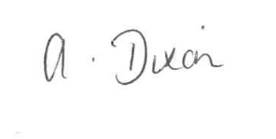
A Dixon
Headteacher

---------------------------------------------------------------------------------------------------------------------

I give permission for my child ____________________________ to visit Darlington Hippodrome on Tuesday 19th December and confirm that an adult will be present to collect them around 4.45pm on their return to school.

Signed_________________________________(parent/carer) __________________(date)

