Firthmoor Primary School
Ingleby Moor Crescent, Darlington, DL1 4RW
Tel: 01325 244001 ● Fax: 01325 244555
Email : admin@firthmoor.darlington.sch.uk
Website : https://www.firthmoor.darlington.sch.uk

Headteacher – Mrs A Dixon



21st November 2017

Dear Parent/Carer,

On Wednesday 29th November 2017, your child will be visiting Newton Aycliffe to take part in a Safety Carousel, organised by Durham & Darlington Fire and Rescue Service.

During the day, they will take part in various workshops and scenarios to learn about staying safe in the home and outdoors.

This event is during school hours and transport is provided. Your child will need a packed lunch and full school uniform must be worn. The packed lunch must not contain fizzy drinks or glass bottles.

If your child is in receipt of Free School Meals, they will be provided with a packed lunch from school.

Please sign and return the consent below as soon as possible.

Yours faithfully

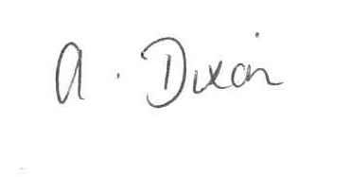
A Dixon
Headteacher

I give permission for my child ………………………………………………………….... to attend the Safety Carousel at Newton Aycliffe, on Wednesday 29th November 2017.

Signed …………………………………………………………… Date …………………………...
(Parent/Carer)

